**INDEX**

1.Abstract…………………………………………………………………………..2

2.Introduction……………………………………………………………………....3

3.Literature Survey………………………………………………………………....6

5.Procedure………………………………………………………………………....7

6.Output…………………………………………………………………………...14

7.Conclusion……………..………………………………………………………..15

8.Future Scope………………………………………………………………….....15

9.Reference……………………………………………………..…………………16

**Abstract:**

This paper scrutinizes the use of different practices and methods in Data Communication and Computer Network, enabling viewer to get the complete concept of different aspects of it. To satisfy this we have implemented the procedure to create a Peer-to-Peer Network (P2P) between two system connected to same network. A little demonstration video was created which is also used as a reference to the output, satisfying every need of a perfect microproject.

**INTRODUCTION**

1. **Data Communication:**

Data transmission and data reception (or, more broadly, data communication or digital communications) is the transfer and reception of data (a digital bitstream or a digitized analog signal) over a point-to-point or point-to-multipoint communication channel. Examples of such channels are copper wires, optical fibers, wireless communication channels, storage media and computer buses. The data are represented as an electromagnetic signal, such as an electrical voltage, radiowave, microwave, or infrared signal. Analog or analogue transmission is a transmission method of conveying voice, data, image, signal or video information using a continuous signal which varies in amplitude, phase, or some other property in proportion to that of a variable.

The messages are either represented by a sequence of pulses by means of a line code (baseband transmission), or by a limited set of continuously varying waveforms (passband transmission), using a digital modulation method. The passband modulation and corresponding demodulation (also known as detection) is carried out by modem equipment. According to the most common definition of digital signal, both baseband and passband signals representing bit-streams are considered as digital transmission, while an alternative definition only considers the baseband signal as digital, and passband transmission of digital data as a form of digital-to-analog conversion.

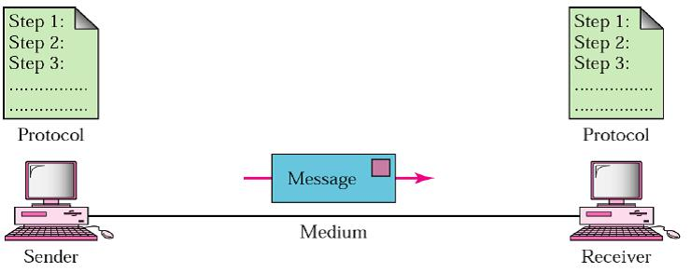

Fig.1. Data Communication

1. **Computer Network:**

A computer network is a group of computers that use a set of common communication protocols over digital interconnections for the purpose of sharing resources located on or provided by the network nodes. The interconnections between nodes are formed from a broad spectrum of telecommunication network technologies, based on physically wired, optical, and wireless radio-frequency methods that may be arranged in a variety of network topologies. The nodes of a computer network may include personal computers, servers, networking hardware, or other specialized or general-purpose hosts. They are identified by hostnames and network addresses. Hostnames serve as memorable labels for the nodes, rarely changed after initial assignment. Network addresses serve for locating and identifying the nodes by communication protocols such as the Internet Protocol.

A computer network extends interpersonal communications by electronic means with various technologies, such as email, instant messaging, online chat, voice and video telephone calls, and video conferencing. A network allows sharing of network and computing resources. Users may access and use resources provided by devices on the network, such as printing a document on a shared network printer or use of a shared storage device. A network allows sharing of files, data, and other types of information giving authorized users the ability to access information stored on other computers on the network. Distributed computing uses computing resources across a network to accomplish tasks.

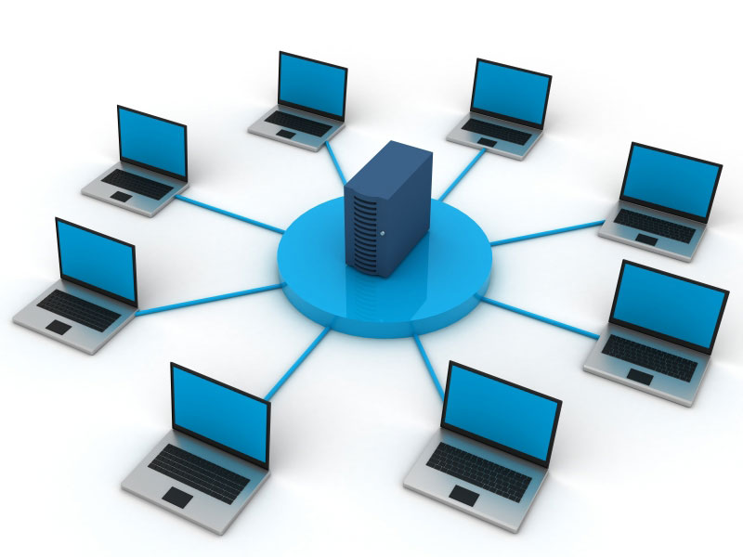

Fig.2. Computer Network

1. **Peer-to-Peer Network (P2P):**

Peer-to-peer (P2P) computing or networking is a distributed application architecture that partitions tasks or workloads between peers. Peers are equally privileged, equipotent participants in the application. They are said to form a peer-to-peer network of nodes. Peers make a portion of their resources, such as processing power, disk storage or network bandwidth, directly available to other network participants, without the need for central coordination by servers or stable hosts. Peers are both suppliers and consumers of resources, in contrast to the traditional client–server model in which the consumption and supply of resources is divided. While P2P systems had previously been used in many application domains, the architecture was popularized by the file sharing system Napster, originally released in 1999. The concept has inspired new structures and philosophies in many areas of human interaction. In such social contexts, peer-to-peer as a meme refers to the egalitarian social networking that has emerged throughout society, enabled by Internet technologies in general.

A peer-to-peer network is designed around the notion of equal peer nodes simultaneously functioning as both "clients" and "servers" to the other nodes on the network. This model of network arrangement differs from the client–server model where communication is usually to and from a central server. A typical example of a file transfer that uses the client–server model is the File Transfer Protocol (FTP) service in which the client and server programs are distinct: the clients initiate the transfer, and the servers satisfy these requests.

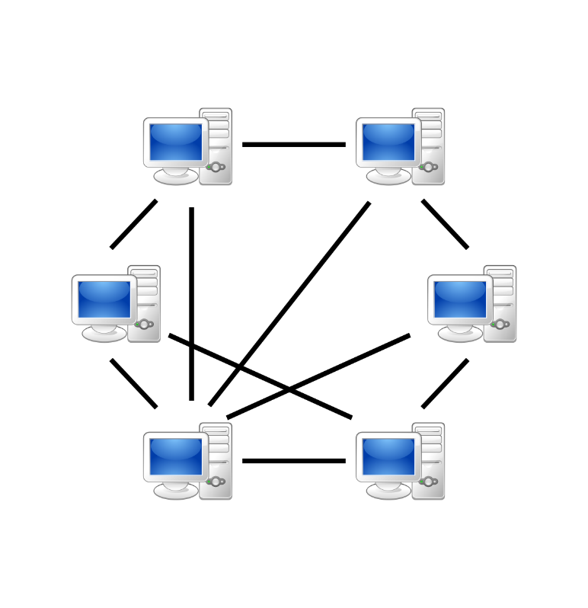

Fig.3. Peer-to-Peer Network (P2P)

**Literature Survey:**

While P2P systems had previously been used in many application domains, the concept was popularized by file sharing systems such as the music-sharing application Napster (originally released in 1999). The peer-to-peer movement allowed millions of Internet users to connect directly, forming groups and collaborating to become user-created search engines, virtual supercomputers, and filesystems. The basic concept of peer-to-peer computing was envisioned in earlier software systems and networking discussions, reaching back to principles stated in the first Request for Comments, RFC 1. In May 1999, with millions more people on the Internet, Shawn Fanning introduced the music and file-sharing application called Napster. Napster was the beginning of peer-to-peer networks, as we know them today, where participating users establish a virtual network, entirely independent from the physical network, without having to obey any administrative authorities or restrictions.

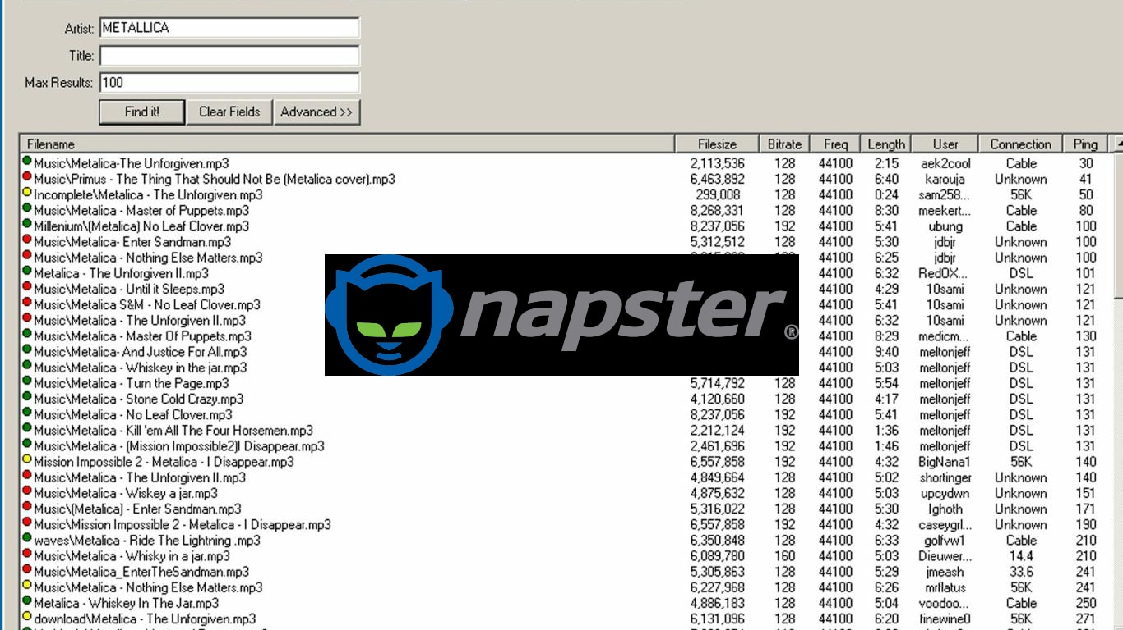

Fig.4. Napster

**Procedure**

**Step 1: Navigate to Desktop**

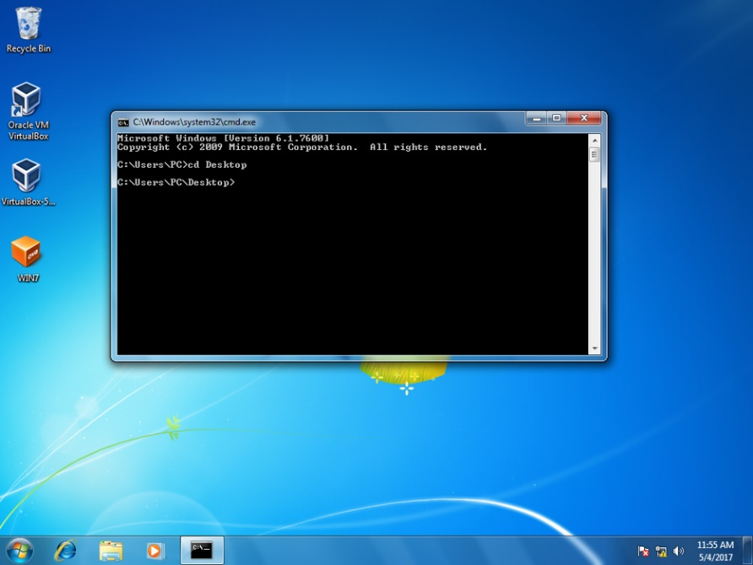

Open command prompt and then use the command <cd Desktop> to change into the desktop directory. This step is simply for convenience so that it is easier to find the folder you're going to be working with.

**Step 2: Create Your Folder**

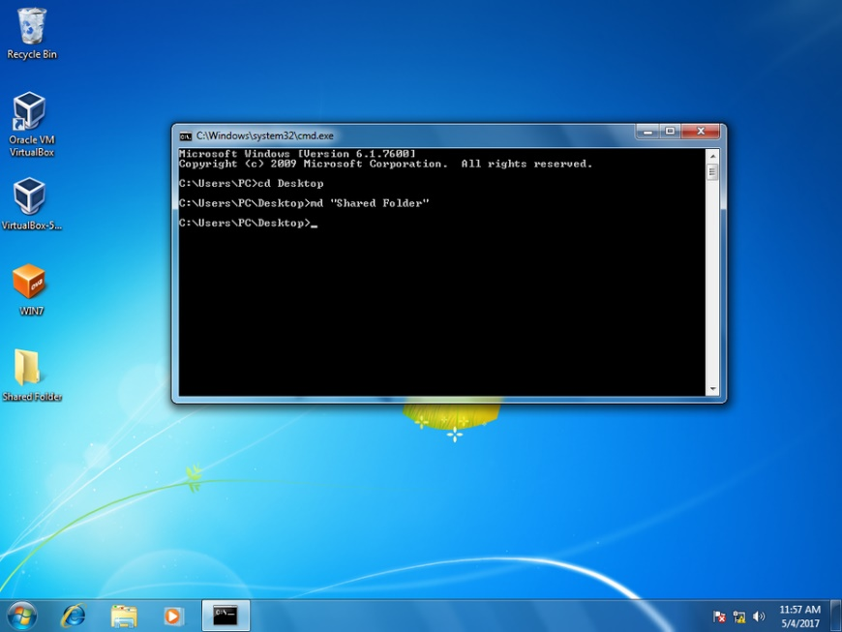

Use the command <md *folder name*> . Make sure that it is visible on your desktop. The command md allows you to create a new folder. After tying md press space and type the name of the folder you want to create.

**Step 3: Navigate to the Folder and Open the Properties**

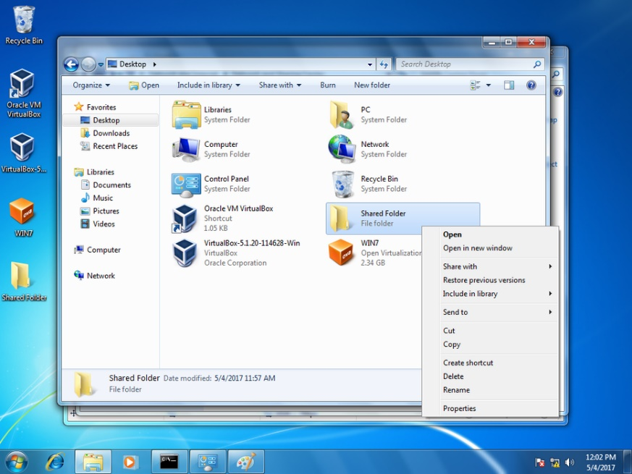

Open the file explorer and go under the Desktop section. Left-click then right-click on the folder. The left-click highlights the folder, and the right-click opens a menu of options. Once the menu of options pops up click on the properties. When you open the properties window go to the sharing section.

**Step 4: Choose Who You Want to Share With.**

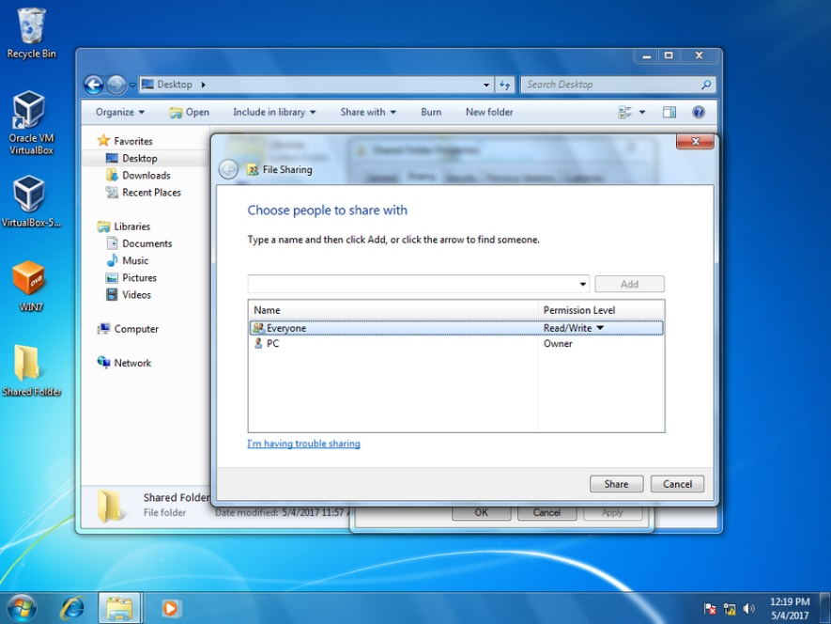

Type <Everyone> and click add. Once you're done with that click share and then go to the advanced sharing. The default setting for the folder is set to only read. This means that if a person accesses the folder they will only be able to view the files and not actually be able to write to the folder.

**Step 5: Sharing the Folder**

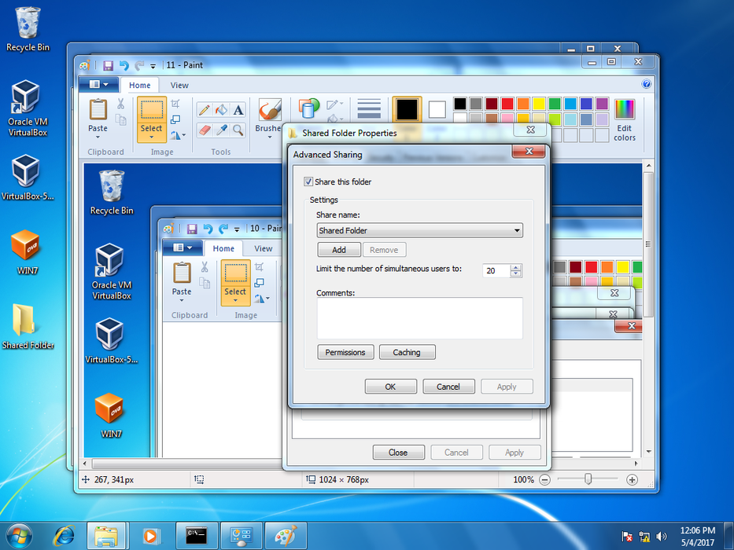

Press the box that lets you share the folder and then go into the permissions section.

**Step 6: Permissions**

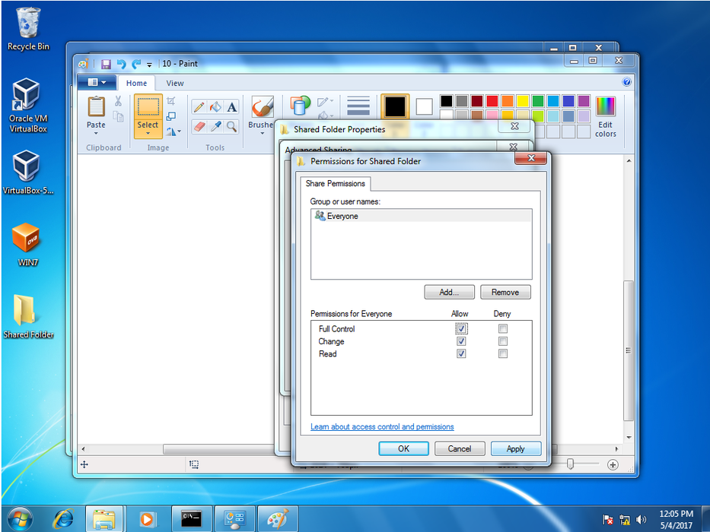

Make sure to give full control to the people that have access to the shared folder. Click Apply then click OK. Once you press OK you'll be back at the advanced sharing page. Press Apply and OK on that page too.

**Step 7: Open Control Panel**

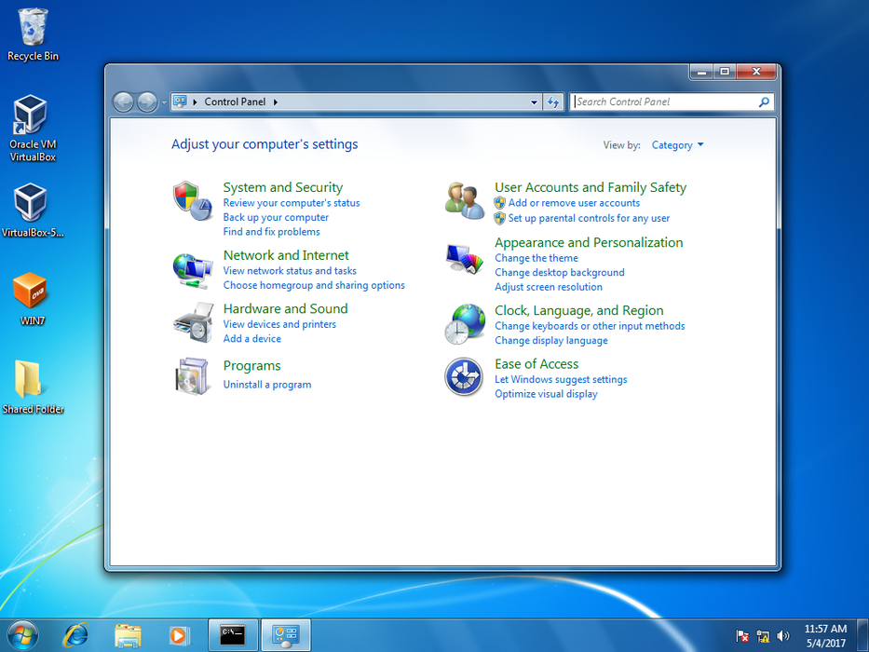

Navigate into the control panel and click on the Network and Internet section.

**Step 8: Network and Sharing**

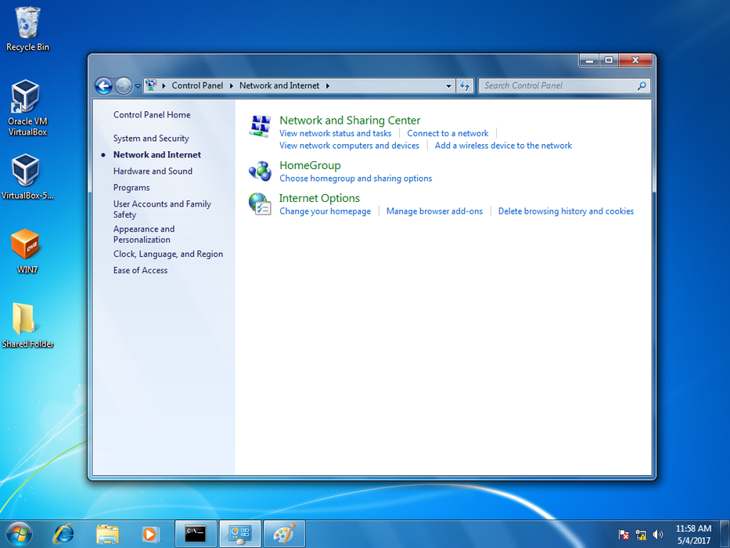

Navigate into the Network and Sharing section.

**Step 9: Advanced Sharing**

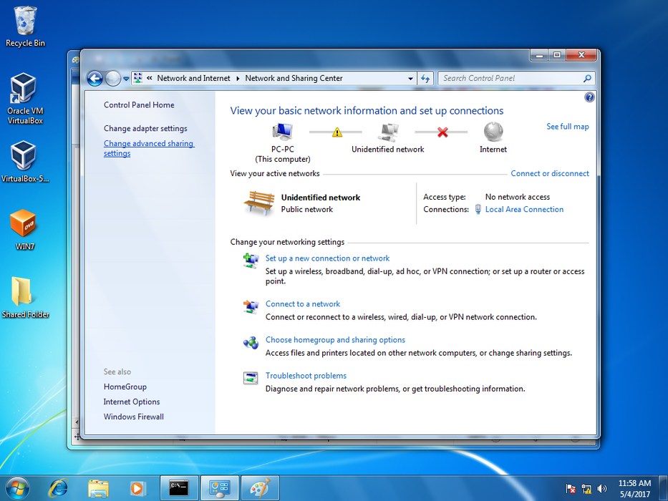

Navigate to the advanced sharing settings.

**Step 10: Choose Home and Work / Public**

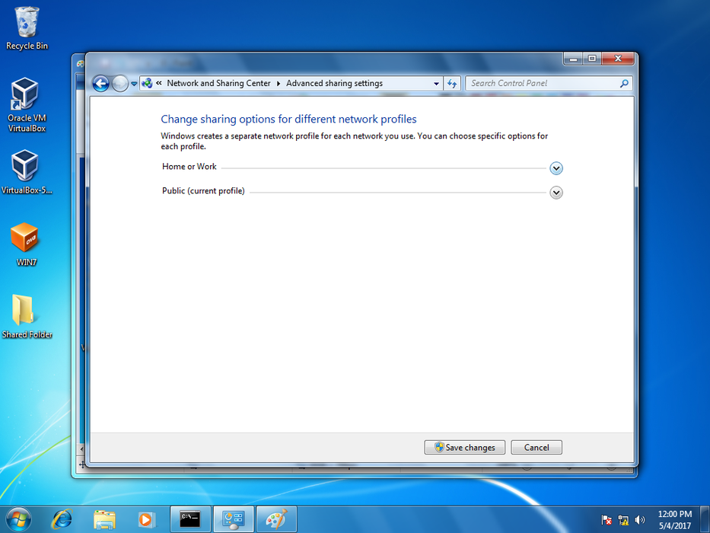

There are many settings that need to be changed in both of the options.

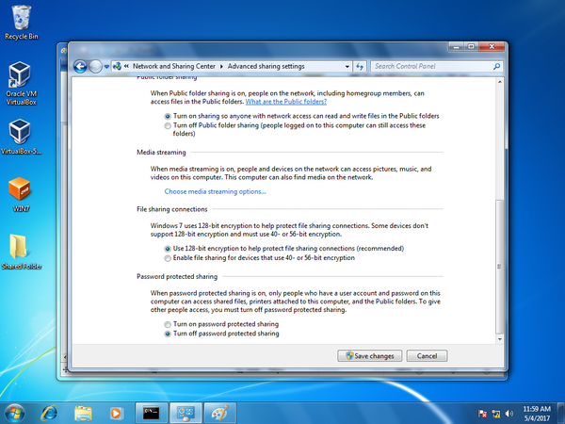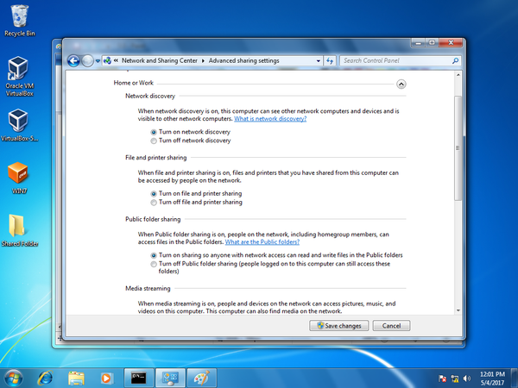**Step 11: Select All Options**

Select All Options

There are going to be many options, the ones you need for the sharing to work are pretty common sense like making sure that your device is allowed to be discovered. And turn off password protected sharing.

**Step 12: Go Into Network**

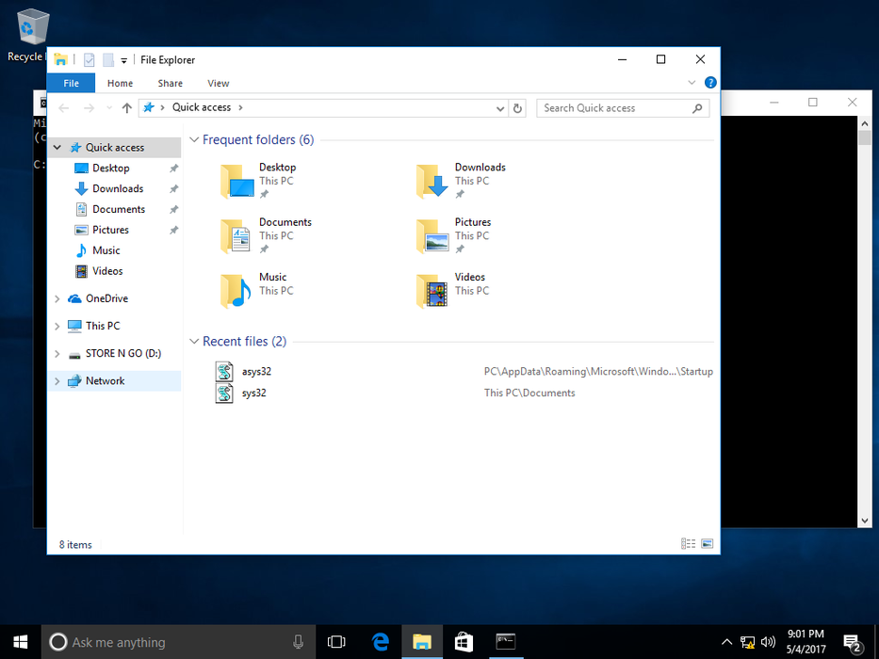

Go onto another computer and open the file explorer. Go into the Network section found on the left hand side at the bottom.

**Step 13: Find the Device**

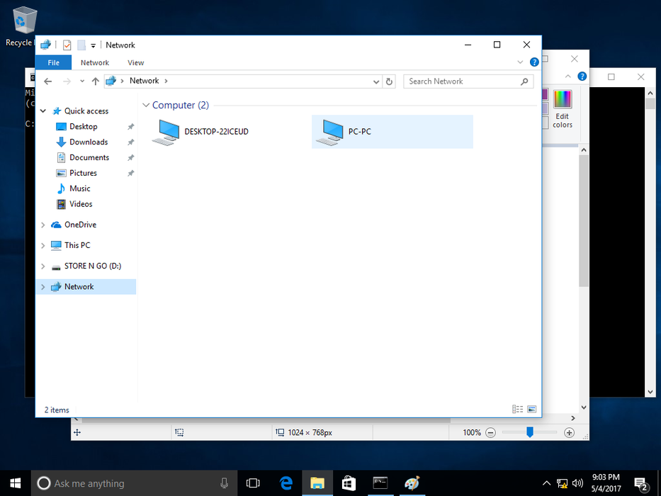

Find the original device that the file was shared from.

**Step 14: Find the Folder That Was Shared**

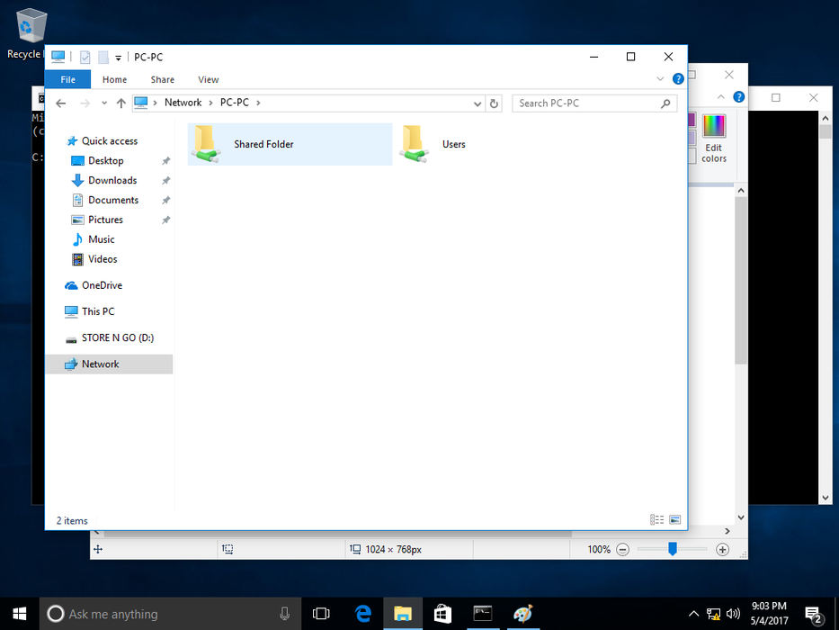

Once you click on the device you will find all the files that were shared from it. You can tell that the folder is shared over the network because it has the green crossroads looking thing under its name.

**Output**

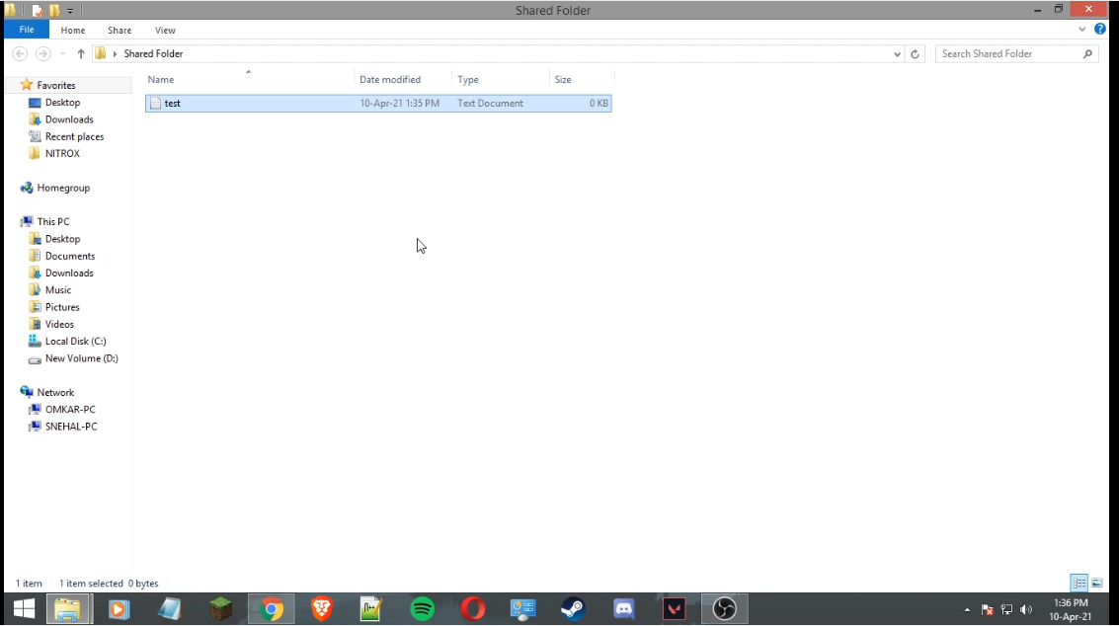

Fig.6.1. Output – System I

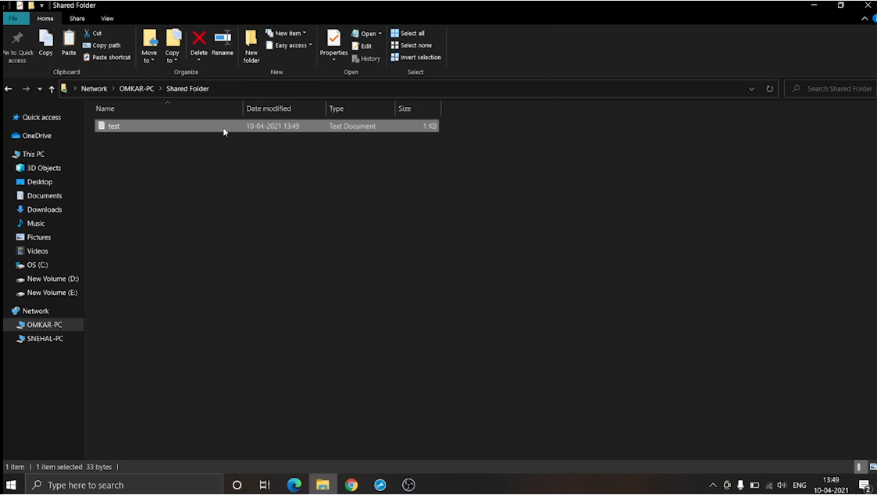

Fig.6.2. Output – System II

**Conclusion**

Computer networks may be classified by many criteria, including the transmission medium used to carry signals, bandwidth, communications protocols to organize network traffic, the network size, the topology, traffic control mechanism, and organizational intent.

Computer networks support many applications and services, such as access to the World Wide Web, digital video, digital audio, shared use of application and storage servers, printers, and fax machines, and use of email and instant messaging applications.

Data transmitted may be digital messages originating from a data source, for example a computer or a keyboard. It may also be an analog signal such as a phone call or a video signal, digitized into a bit-stream, for example, using pulse-code modulation (PCM) or more advanced source coding (analog-to-digital conversion and data compression) schemes. This source coding and decoding is carried out by codec equipment.

While P2P systems had previously been used in many application domains, the architecture was popularized by the file sharing system Napster, originally released in 1999.The concept has inspired new structures and philosophies in many areas of human interaction. In such social contexts, peer-to-peer as a meme refers to the egalitarian social networking that has emerged throughout society, enabled by Internet technologies in general.

**Future Scope**

In P2P networks, clients both provide and use resources. This means that unlike client–server systems, the content-serving capacity of peer-to-peer networks can actually increase as more users begin to access the content (especially with protocols such as Bittorrent that require users to share, refer a performance measurement study). This property is one of the major advantages of using P2P networks because it makes the setup and running costs very small for the original content distributor.

Peer-to-peer networking involves data transfer from one user to another without using an intermediate server. Companies developing P2P applications have been involved in numerous legal cases, primarily in the United States, over conflicts with copyright law. Two major cases are Grokster vs RIAA and MGM Studios, Inc. v. Grokster, Ltd.. In the last case, the Court unanimously held that defendant peer-to-peer file sharing companies Grokster and Streamcast could be sued for inducing copyright infringe

**References**

1. <https://en.wikipedia.org/wiki/Peer-to-peer>
2. <https://en.wikipedia.org/wiki/Data_communication>
3. <https://en.wikipedia.org/wiki/Computer_network>